Title: Credit Card Approval Prediction

Project Description:
Credit Card Approval Prediction is an intelligent machine learning-based system designed to automate and improve the credit card application approval process. The system analyzes applicant information such as age, income, employment status, education, credit history, loan details, and financial behavior to determine whether a credit card application should be approved or rejected. By utilizing data preprocessing techniques and classification algorithms, the model identifies patterns in historical customer data and predicts approval outcomes with high accuracy. This automated approach minimizes manual effort, reduces processing time, and supports financial institutions in making consistent and data-driven credit decisions.

The application is developed using Python and integrates machine learning libraries such as Pandas, NumPy, Scikit-learn, and Matplotlib for data analysis, model training, and performance evaluation. A user-friendly interface enables users or bank officials to enter applicant details and receive instant approval predictions based on the trained model. The system follows a structured workflow that includes data collection, preprocessing, feature engineering, model training, prediction, and result visualization. By enhancing decision-making accuracy and reducing the risk of approving high-risk applicants, the Credit Card Approval Prediction system provides a reliable, scalable, and efficient solution for modern banking and financial services, with future scope for real-time data integration, fraud detection, and explainable AI-based decision support.

Scenarios
Scenario 1: A salaried employee applies for a credit card by entering details such as age, monthly income, employment status, and credit history. The system analyzes the information and predicts that the applicant is eligible. The application is marked as Approved based on the applicant's good financial profile

Scenario 2: A customer with a low credit score, unstable income, and previous loan defaults submits a credit card application. The machine learning model evaluates the risk associated with the applicant and predicts that the application should be Rejected to reduce financial risk.
Scenario 3: A self-employed individual with a stable annual income and a good repayment history applies for a credit card. After analyzing the provided details, the system predicts that the applicant qualifies for a credit card and displays the result as Approved.

Technical Architecture:

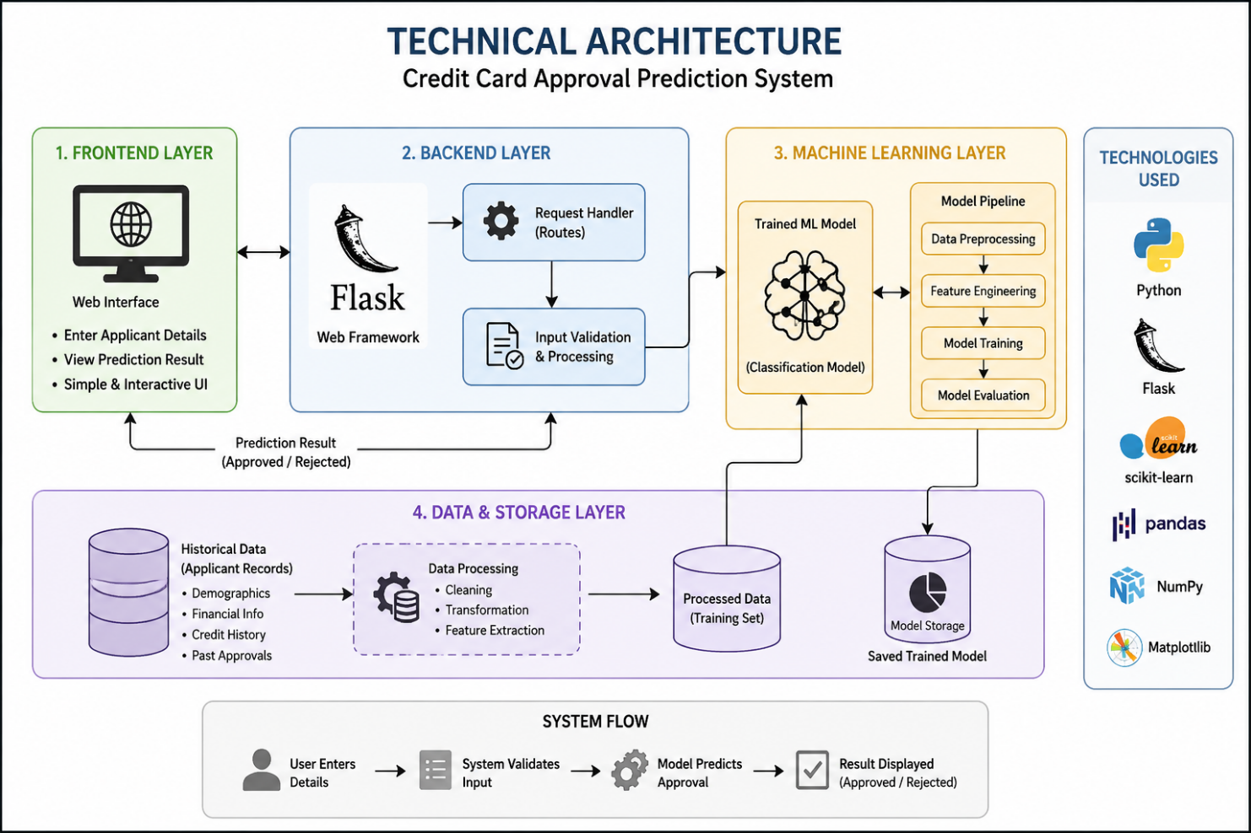

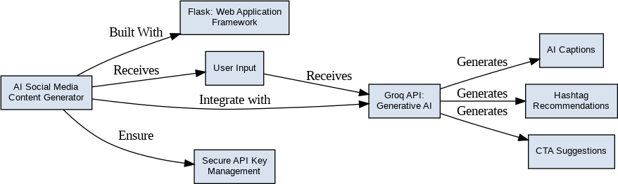
Description: utilizes a modular three-tier architecture to deliver rapid, AI-driven content generation. The frontend provides a responsive user interface built with HTML and CSS while the Flask-based backend orchestrates data validation and prompt construction. It interfaces with the Groq API using the LLaMA 3.3-70B model to generate tailored social media content, with secure deployment managed locally via Flask and exposed publicly through Ngrok.

(Note: If you are using database in your project definitely you need to add ER Diagram along with description)

Pre-requisites:
- Flask Framework Knowledge: Flask Documentation
- Groq API Familiarity: Groq API Documentation
- HTML, CSS, and JavaScript Skills: W3Schools HTML/CSS/JavaScript Tutorials
- Python Programming Proficiency: Python Documentation
- Version Control with Git: Git Documentation
- Development Environment Setup: Flask Installation Guide
- Ngrok for Public Deployment: Ngrok Documentation

Project Workflow:

Milestone 1: Model Selection and Architecture
- Activity 1.1: Generate a Groq API key and configure it securely in the project environment.
- Activity 1.2: Research and select the appropriate generative AI model from Groq for social media content generation.
- Activity 1.3: Define the architecture of the application, detailing interactions between the frontend, backend, and AI integration.
- Activity 1.4: Set up the development environment, installing necessary libraries and dependencies for Flask and the Groq API.

Milestone 2: Core Functionalities Development
- Activity 2.1: Develop the core functionalities: Caption Generator, Hashtag Suggester, and Call-to-Action Generator.
- Activity 2.2: Implement the Flask backend to manage routing and user input processing, ensuring smooth API interactions.

Milestone 3: App.py Development
- Activity 3.1: Write the main application logic in app.py, establishing routes for each feature and integrating AI responses.

Milestone 4: Frontend Development
- Activity 4.1: Design and develop the user interface using HTML, CSS, and JavaScript, ensuring a responsive and intuitive layout.
- Activity 4.2: Create dynamic templates with Flask’s render_template to display results based on user interactions.

Milestone 5: Deployment
- Activity 5.1: Prepare the application for local deployment by configuring the server environment and ensuring all dependencies are correctly installed.
- Activity 5.2: Deploy the application publicly using Ngrok to expose the local Flask server over a secure public URL.

Milestone 6: Conclusion

Milestone 1: Model Selection and Architecture
In this milestone, we focus on selecting the appropriate generative AI model from Groq for our social media content generation needs. This involves researching the capabilities and performance of various models that Groq offers, ensuring that the chosen model aligns well with the application’s objectives of generating captions, hashtags, and CTAs across different platforms and tones.

Activity 1.1: Generate a Groq API Key
Before the application can communicate with the Groq LLM, you need a valid Groq API key. Follow the steps below to create one and connect it securely to the project.
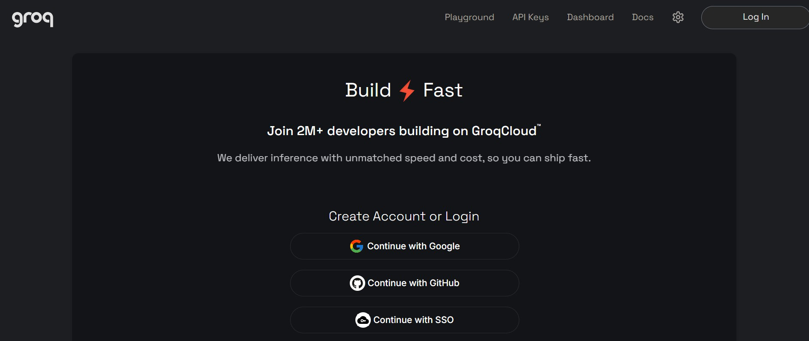
- Step 1 — Create a Groq Account: Visit https://console.groq.com and sign up for a free account using your Google account or email address.

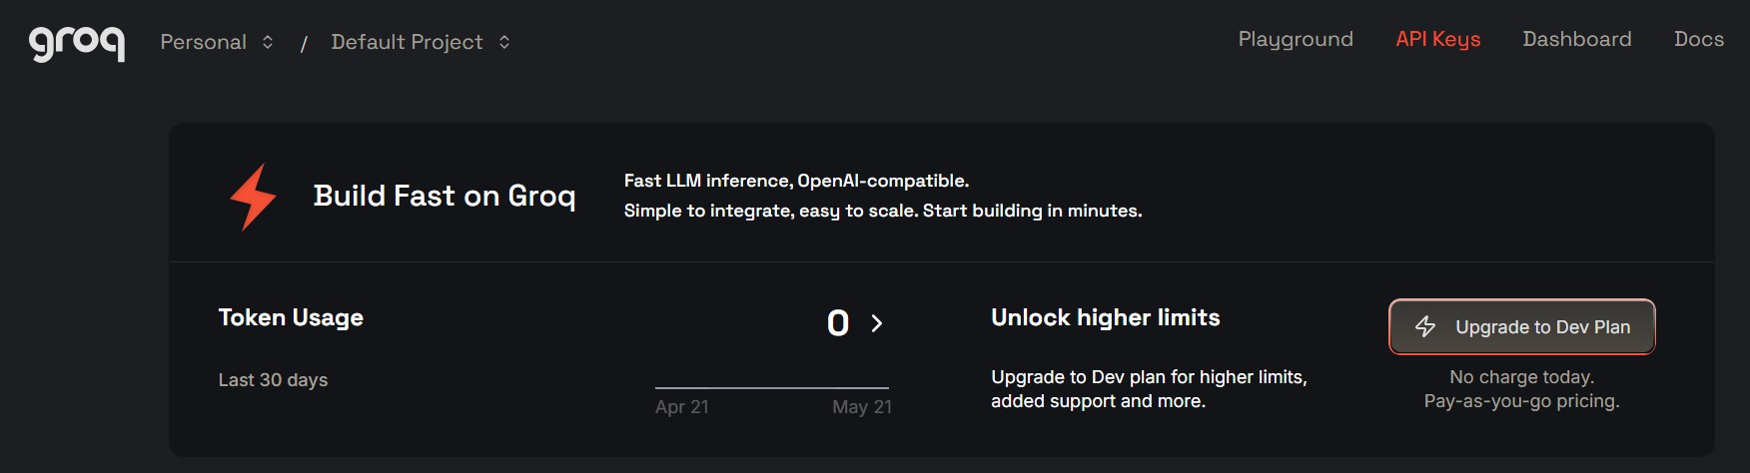
- Step 2 — Navigate to API Keys: After logging in, click on your profile icon in the top-right corner and select “API Keys” from the dropdown menu, or go directly to the API Keys page.

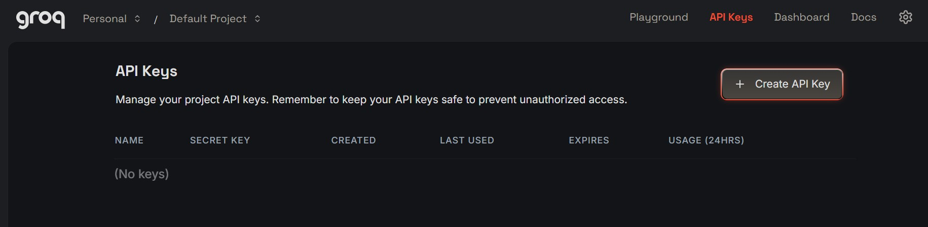
- Step 3 — Create a New API Key: Click the “Create API Key” button. Give your key a descriptive name (e.g., captionai-key) so it is easy to identify later.

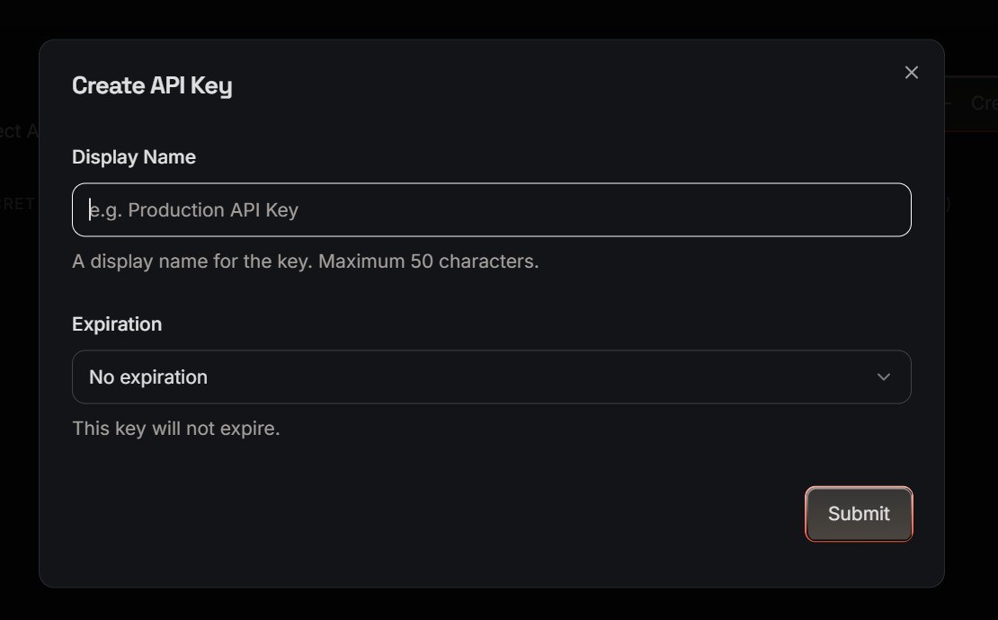
- Step 4 — API Key: Now give a “Display Name” and “Expiration” is optional, and Click on “Submit”. The you will get your API key, Copy it immediately and store it in a safe place you will not be able to view it again after closing the dialog.

- Step 5 — Add the Key to Your Project: Create a .env file in the root of your project directory (if it does not already exist) and paste the key as shown below: GROQ_API_KEY=your_copied_api_key_here
- Step 6 — Verify the Key is Loaded: The app.py file loads this key automatically at startup using python-dotenv:
from dotenv import load_dotenv load_dotenv()
client = Groq(api_key=os.environ.get("GROQ_API_KEY"))
- Important — Never Commit Your API Key: Add .env to your .gitignore file to prevent accidentally pushing the key to a public repository:
.env

Activity 1.2: Research and Select the Appropriate Generative AI Model
Here are the things that needed to research to select a best model for the project:
  - Understand the Project Requirements: Review the specific needs of the CaptionAI application, focusing on the types of content it will generate (captions, hashtags, and calls-to-action across Instagram and LinkedIn).
  - Explore Groq’s Model Documentation: Visit the Groq documentation to examine the available LLM models, including their functionalities, context windows, speed, and limitations.
  - Evaluate Model Performance: Compare models based on response quality, generation speed, and relevance to social media copywriting tasks.
  - Select the Optimal Model: Choose llama-3.3-70b-versatile for its balance of creative output quality and generation speed, set with a temperature of 0.8 and max_tokens of 2048 for rich, varied captions.

Activity 1.3: Define the Architecture of the Application
  - Draft an Architectural Diagram: Create a visual representation of the application architecture, including components like the frontend (HTML, CSS, JavaScript), Flask backend, and Groq API integration.
  - Detail Frontend Functionality: Outline how users interact with the application entering product/campaign information, selecting a platform (Instagram or LinkedIn), and choosing a tone (Professional, Casual, or Promotional).
  - Outline Backend Responsibilities: Specify how the Flask backend handles incoming POST requests to /generate, validates and sanitizes user input, builds a structured prompt, and communicates with the Groq API.
  - Describe AI Integration Points: Define how the backend constructs prompts using TONE_DESCRIPTIONS and PLATFORM_TIPS dictionaries, calls the Groq API, parses the JSON response via extract_json(), and returns structured results to the frontend.

Activity 1.4: Set Up the Development Environment
  - Install Python and Pip: Ensure Python 3.8+ is installed on your machine along with pip for dependency management.
  - Create a Virtual Environment: Set up a virtual environment using venv to isolate project dependencies:
D:\projects>python -m venv myenv D:\projects>"d:\projects\venv\Scripts\activate"
(myenv) D:\projects> pip install -r requirements.txt
  - Install Flask: Use pip to install Flask:
(myenv) D:\projects> pip install Flask==3.0.3
  - Install Groq SDK: Install the Groq Python library to interact with the Groq API:
(myenv) D:\projects> pip install groq==0.11.0
  - Install python-dotenv: Install dotenv support for secure API key management:
(myenv) D:\projects> pip install python-dotenv==1.0.1
  - Configure the API Key: Create a .env file in the project root and add your Groq API key:
GROQ_API_KEY=your_groq_api_key_here
  - Set Up Application Structure: Create the project directory structure including folders for templates, static files (CSS, JS), and main application files (app.py, requirements.txt, run_public.py).
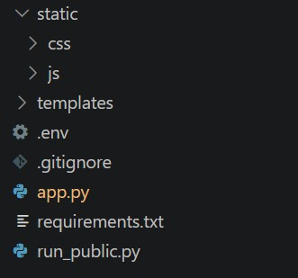

Milestone 2: Core Functionalities Development

Activity 2.1: Develop Core Content Generation Features
Implement the three core generation features Captions, Hashtags, and CTAs as a unified AI response driven by a single structured prompt.
  - Caption Generator: Generates three unique, platform-appropriate captions. For Instagram/Casual tone, includes relevant emojis and conversational language. For LinkedIn/Professional tone, produces insight-led, value-driven copy.
  - Hashtag Suggester: Produces ten hashtags per request a curated mix of high-reach popular tags and targeted niche tags relevant to the product or campaign.
  - CTA Generator: Returns three short (under 10 words), punchy, action-oriented call-to-action phrases calibrated to the selected platform and tone.

Activity 2.2: Implement the Flask Backend

Define Routes in Flask:
- Set up routes in app.py for the home page and content generation endpoint.

Process User Input:
- Create a form in index.html for users to submit their product/campaign information, platform, and tone.
- Use Flask’s request.get_json() to retrieve JSON data submitted from the frontend via AJAX.
- Validate that product_info is non-empty and within the 2000-character limit before processing.

Integrate API Calls:
- Within the /generate route handler, call the build_prompt() function to construct a structured prompt combining tone descriptions and platform-specific tips.
- Submit the prompt to the Groq API using client.chat.completions.create() with the llama-3.3-70b-versatile model.
- Parse and validate the JSON response using extract_json(), which handles direct JSON, markdown code blocks, and raw JSON object extraction as fallback strategies.

Milestone 3: App.py Development
Milestone 3 focuses on creating and refining the core logic of the app.py file, which serves as the backbone of the CaptionAI application. In this milestone, you’ll set up each feature’s functionality through Flask routes, establish reliable prompt construction and API interaction, and conduct unit testing to ensure each feature performs as expected.

Activity 3.1: Writing the Main Application Logic in app.py

Define the Core Routes in app.py:
- Establish routes for CaptionAI’s two endpoints, each serving a distinct purpose:
  - / — Home page route that renders the main index.html interface
@app.route("/") def index():
return render_template("index.html")

  - /generate — POST endpoint that accepts JSON input, invokes the AI, and returns structured content
@app.route("/generate", methods=["POST"]) def generate():
data = request.get_json()
product_info = data.get("product_info", "").strip() platform = data.get("platform", "instagram").lower() tone = data.get("tone", "professional").lower()
if not product_info:
return jsonify({"error": "Product information is required."}), 400 if len(product_info) > 2000:
return jsonify({"error": "Input too long. Please keep it under 2000 characters."}), 400
try:
prompt = build_prompt(product_info, platform, tone)

chat_completion = client.chat.completions.create( messages=[
{
"role": "system",
"content": "You are a social media content expert. Always respond with valid JSON only, no markdown formatting."
},
{
"role": "user", "content": prompt
}
],
model="llama-3.3-70b-versatile", temperature=0.8, max_tokens=2048,

)
response_text = chat_completion.choices[0].message.content result = extract_json(response_text)
# Validate structure
if not all(k in result for k in ["captions", "hashtags", "ctas"]): raise ValueError("Invalid response structure from AI")
return jsonify({ "success": True,
"captions": result["captions"], "hashtags": result["hashtags"], "ctas": result["ctas"], "platform": platform,
"tone": tone
})
except ValueError as e: import traceback traceback.print_exc()
return jsonify({"error": f"Failed to parse AI response: {str(e)}"}), 500 except Exception as e:
import traceback traceback.print_exc()
return jsonify({"error": f"Generation failed: {str(e)}"}), 500

Set Up Route Handlers for Each Feature:
- For the /generate route, implement logic that reads product_info, platform, and tone from the incoming JSON body using request.get_json().
- Apply input validation: return a 400 error if product_info is empty or exceeds 2000 characters.
- Route AJAX requests from the frontend to the /generate endpoint, which processes data and returns a JSON response.

Define Prompt Engineering Helpers:
- TONE_DESCRIPTIONS dictionary: maps professional, casual, and promotional tones to detailed copywriting instructions embedded in the prompt.

TONE_DESCRIPTIONS = {
"professional": "formal, authoritative, and business-oriented. Use clear, concise language that conveys expertise and credibility.",
"casual": "friendly, conversational, and relatable. Use informal language, emojis, and a warm tone that feels personal.",
"promotional": "exciting, persuasive, and action-driven. Use power words, urgency, and compelling offers to drive engagement."
}

- PLATFORM_TIPS dictionary: maps instagram and linkedin to platform-specific content guidelines (character limits, style expectations).

PLATFORM_TIPS = {
"instagram": "optimized for Instagram — visually descriptive, emotionally engaging, with strong visual storytelling. Max 2200 characters.",
"linkedin": "optimized for LinkedIn — professional insights, value-driven, thought leadership style. Max 3000 characters."
}

- build_prompt(): assembles a structured prompt string from the product info, selected platform tip, and tone description, instructing the model to return strictly valid JSON.

def build_prompt(product_info: str, platform: str, tone: str) -> str: tone_desc = TONE_DESCRIPTIONS.get(tone, "engaging")
platform_tip = PLATFORM_TIPS.get(platform, "social media")

return f"""You are an expert social media content strategist and copywriter.

Integrate the Groq AI Responses in Each Function:
- Call client.chat.completions.create() with a system message enforcing JSON-only responses and a user message containing the assembled prompt.
- extract_json(): a robust parser that first attempts direct json.loads(), then strips markdown code fences (```json blocks), and finally uses a regex to locate a raw JSON object ensuring reliable parsing across model response variations.
def extract_json(text: str) -> dict:
"""Extract JSON from LLM response, handling markdown code blocks.""" # Try direct parse first
try:
return json.loads(text) except json.JSONDecodeError:
pass
# Try extracting from markdown code block
match = re.search(r'```(?:json)?\s*([\s\S]*?)```', text) if match:
try:
return json.loads(match.group(1).strip()) except json.JSONDecodeError:
pass
match = re.search(r'\{[\s\S]*\}', text) if match:
try:
return json.loads(match.group(0)) except json.JSONDecodeError:
pass
raise ValueError("Could not extract valid JSON from response")

- Validate that the parsed result contains all three required keys — captions, hashtags, and ctas — before returning it to the frontend.
- Home route: / → renders index.html/generate (POST) → accepts JSON, returns
{success,captions, hashtags, ctas, platform, tone}

Milestone 4: Frontend Development
Milestone 4 focuses on developing a user-friendly and visually appealing interface for CaptionAI. This involves designing a glassmorphism-style layout with responsive HTML and CSS to enhance usability, and creating dynamic content rendering with vanilla JavaScript to display AI-generated captions, hashtags, and CTAs based on user interactions.

Activity 4.1: Designing and Developing the User Interface

Set Up the Base HTML Structure:
- Develop the main HTML file (index.html) as the single-page interface, including a header with the CaptionAI brand logo and tagline, an input section, and a results section.
- Use semantic HTML elements to keep the structure organized and ensure the interface is accessible for all users.
- Integrate Font Awesome icons for platform indicators and result section headings, and Google Fonts (Inter) for clean typography.

Design a Responsive Layout Using CSS:
- Create a CSS stylesheet (static/css/style.css) implementing a dark glassmorphism aesthetic with animated background blobs (blob-1, blob-2, blob-3) for visual depth.
- Use flexbox and grid layouts to organize the results into a two-column structure (captions on the left, hashtags and CTAs on the right).
- Add media queries to ensure the layout adapts across desktop, tablet, and mobile screen sizes.

Create Separate UI Components for Each Output Type:
- Caption Cards: individual cards per caption, each with a one-click copy-to-clipboard button that provides visual feedback (checkmark + green highlight for 2 seconds).
- Hashtag Chips: rendered as pill-shaped chip elements inside a glass card, with automatic # prefix validation.
- CTA List: displayed as a clean unordered list inside a separate glass card with a bullhorn icon header.

Activity 4.2: Creating Dynamic Content Rendering with JavaScript

Handle Form Submission Asynchronously:
- Attach a submit event listener to the generator form that prevents default form submission and sends the data as a JSON POST request to /generate via the Fetch API.
- During loading, disable the submit button and show an animated CSS loader in place of the button text and arrow icon.

Render Results Dynamically:
- Implement the renderResults(data) function in main.js, which dynamically creates and injects DOM elements for captions, hashtags, and CTAs into their respective containers.
- After rendering, automatically smooth-scroll the viewport to the results section using scrollIntoView().

Restore UI State After Generation:
- In the finally block of the async handler, re-enable the submit button and restore the original button text and icon regardless of success or failure.

Milestone 5: Deployment
In Milestone 5, the focus is on deploying the CaptionAI application first locally to verify correct operation, and then publicly via Ngrok to share the app over a secure, accessible URL. This involves configuring the server environment, managing dependencies, and launching the app for real-world use.

Activity 5.1: Preparing the Application for Local Deployment

Set Up a Virtual Environment:
- Open a New Terminal
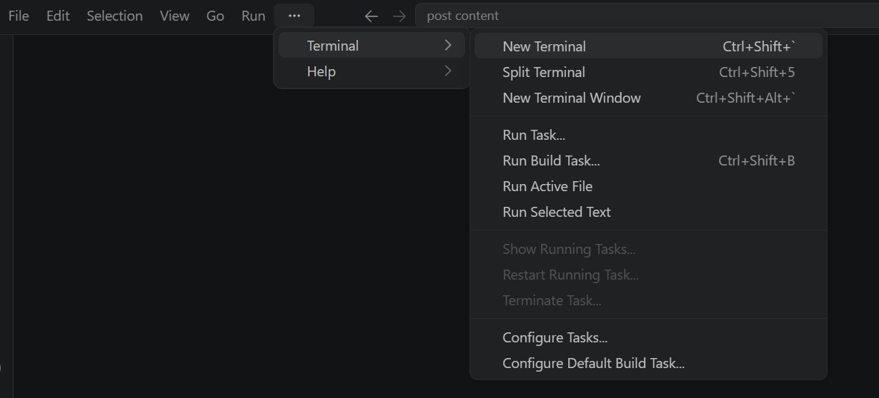
- Then open “Command Prompt”
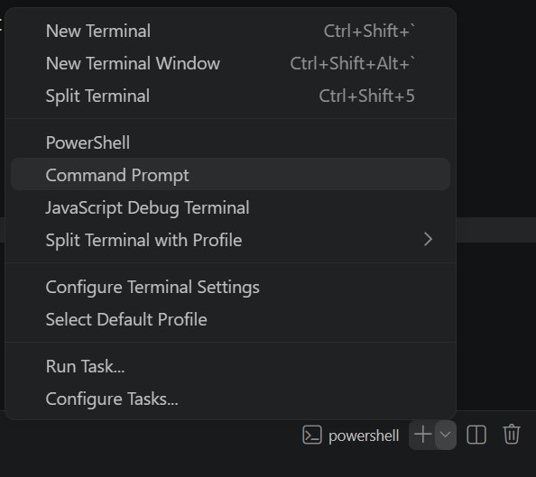

- Create and activate a virtual environment, then install all required dependencies from requirements.
D:\projects>python -m venv myenv D:\projects>"d:\projects\venv\Scripts\activate" (myenv) D:\projects>pip install -r requirements.txt

Configure Environment Variables:
- Create a .env file in the project root and add your Groq API key. The app loads this automatically using python-dotenv at startup:
GROQ_API_KEY=your_groq_api_key_here

Activity 5.2: Local Testing and Verification

Start the Flask Development Server:
- Run the application locally using:
(myenv) D:\projects>python app.py
- Once running, open a browser and navigate to “http://127.0.0.1:5050” to access the app.
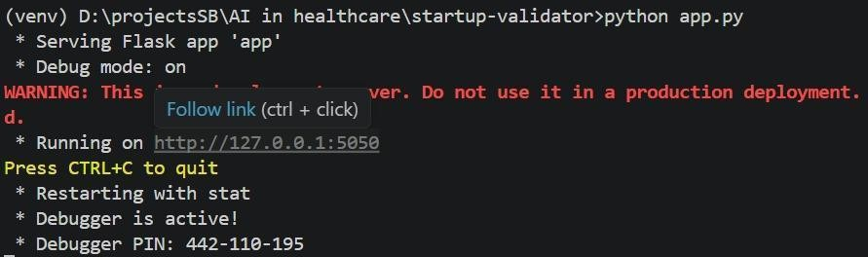
- Interact with the caption generator test all three tones (Professional, Casual, Promotional) and both platforms (Instagram, LinkedIn) to verify the AI responses are correctly generated, parsed, and rendered.

Activity 5.3: Public Deployment via Ngrok
Ngrok creates a secure tunnel from a public URL to your local Flask server, making the app accessible from anywhere without a cloud hosting provider.

Install Ngrok and pyngrok:
- Install the pyngrok Python wrapper, which manages Ngrok programmatically within your Python project:
D:\projects>pip install pyngrok
- Download and install the Ngrok client from https://ngrok.com/download.
- Click on “Microsoft Store Installer”.
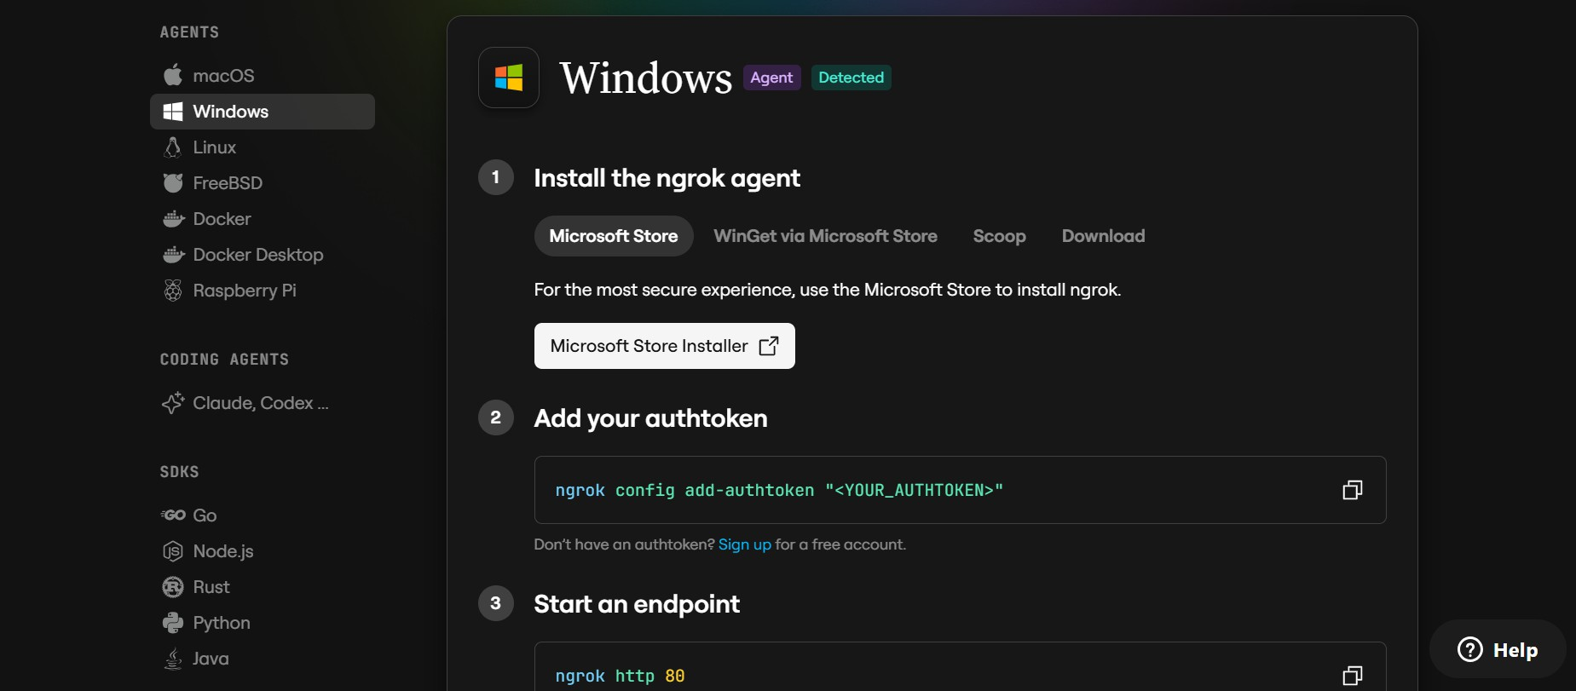

Configure Your Ngrok Authtoken:
- Sign up at ngrok.com and copy your authtoken from the Ngrok dashboard.
- The run_public.py script sets the authtoken automatically using:
D:\projects>ngrok.set_auth_token("YOUR_NGROK_AUTHTOKEN")
- Replace the TOKEN value in run_public.py with your own Ngrok authtoken before running.

Run the Public Deployment Script:
- Instead of running app.py directly, launch run_public.py to start both the Ngrok tunnel and the Flask server:
D:\projects>python run_public.py
- The script opens an HTTP tunnel on port 5000 and prints the live public URL in the terminal:
====================================================== YOUR PUBLIC WEBSITE URL IS LIVE!
URL: https://xxxx-xx-xx-xxx-xx.ngrok-free.app
======================================================

- Share this URL with anyone who can access your CaptionAI app directly from their browser without any installation.

Important Notes:
- debug=False is required in run_public.py to prevent Flask from spawning a reloader process, which would interfere with Ngrok’s tunnel management.
- The public URL changes each time you restart run_public.py (on the free Ngrok plan). For a persistent URL, upgrade to a paid Ngrok plan and configure a reserved domain.
- Ngrok free tier sessions expire after a few hours of inactivity. Restart run_public.py to get a new URL when this happens.

Exploring the Website’s Web Pages:

Home / Generator Page:
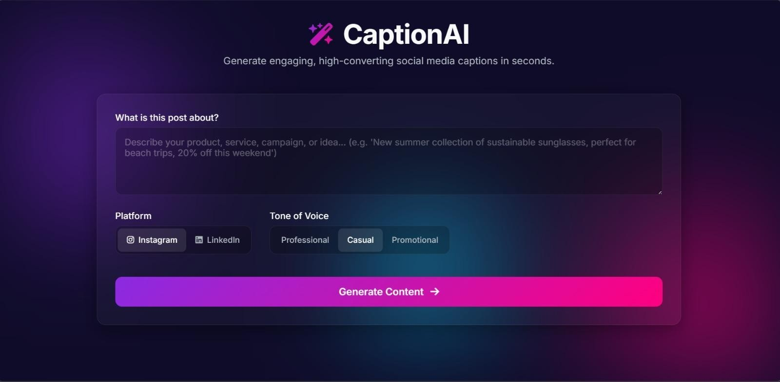
Description: The single-page interface of CaptionAI serves as both the landing page and the generation tool. It features a dark glassmorphism design with animated background blobs, a header displaying the CaptionAI brand (wand-magic-sparkles icon + logo), and a tagline. The main section contains the input form, platform toggle, tone selector, and the AI-generated results panel all on one seamless page.

Input Section:
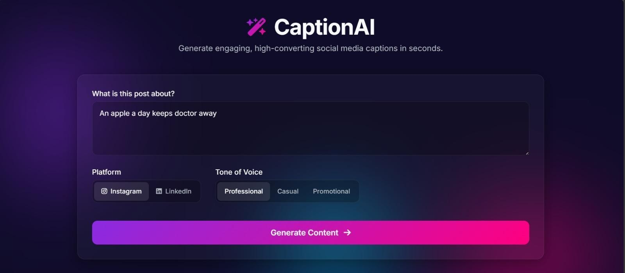
Description: A glass-styled card containing the main generation form. Users enter their product, service, or campaign description in a textarea (up to 2000 characters), select their target platform via a toggle button group (Instagram or LinkedIn), choose their tone of voice (Professional, Casual, or Promotional), and click the Generate Content button. While the AI processes the request, the button transitions to an animated loading spinner.

Results Section:
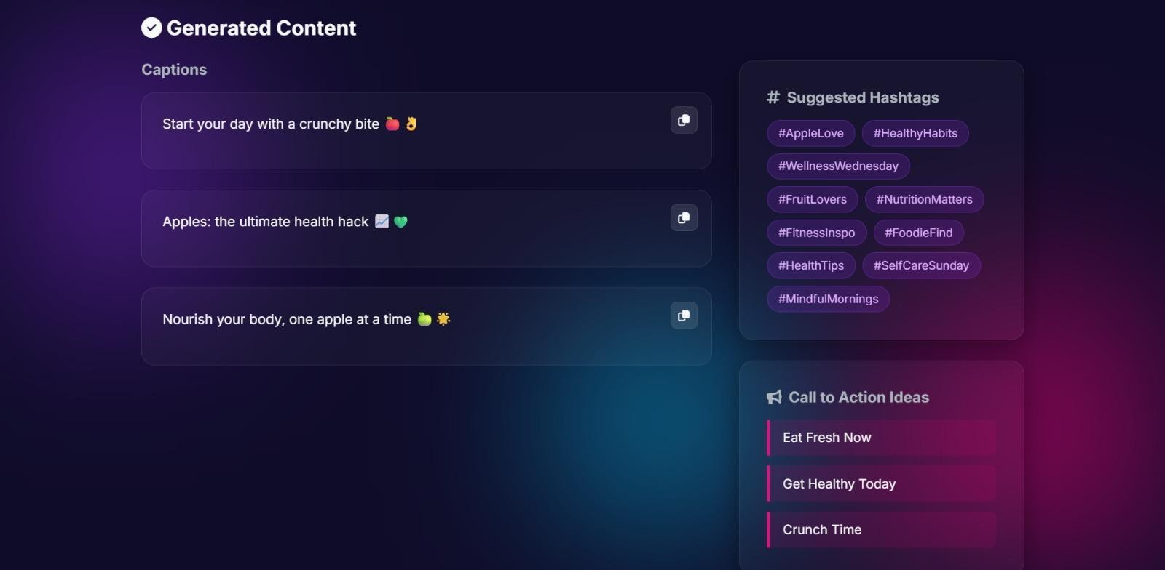
Description: Revealed dynamically after generation, this section displays the AI output in a
two-column grid. The left column shows three caption cards, each with the generated caption text and a copy-to-clipboard button. The right column contains two glass cards: one with ten hashtag chips (prefixed with #) and one with three CTA phrases in a list format. The viewport automatically smooth-scrolls to this section upon content generation.

Conclusion:
CaptionAI is a generative AI platform built with Flask and styled with a glassmorphism UI that streamlines social media content creation. It uses Groq’s high-speed inference API with the LLaMA 3.3-70B Versatile model to instantly generate tailored captions, hashtags, and calls-to-action for Instagram and LinkedIn across professional, casual, and promotional tones. The project, which included model selection, development, and deployment via Ngrok, highlights how targeted AI and a structured framework can boost productivity for marketers and creators, with potential for future scalability. Looking ahead, CaptionAI offers significant opportunities for expansion, such as integrating multi-language support, adding image analysis capabilities for visual-context generation, and implementing user authentication to save generation history. By continuously refining the underlying model prompts and enhancing the frontend accessibility, the platform is well-positioned to evolve from a specialized tool into a comprehensive social media management assistant for teams of all sizes.

